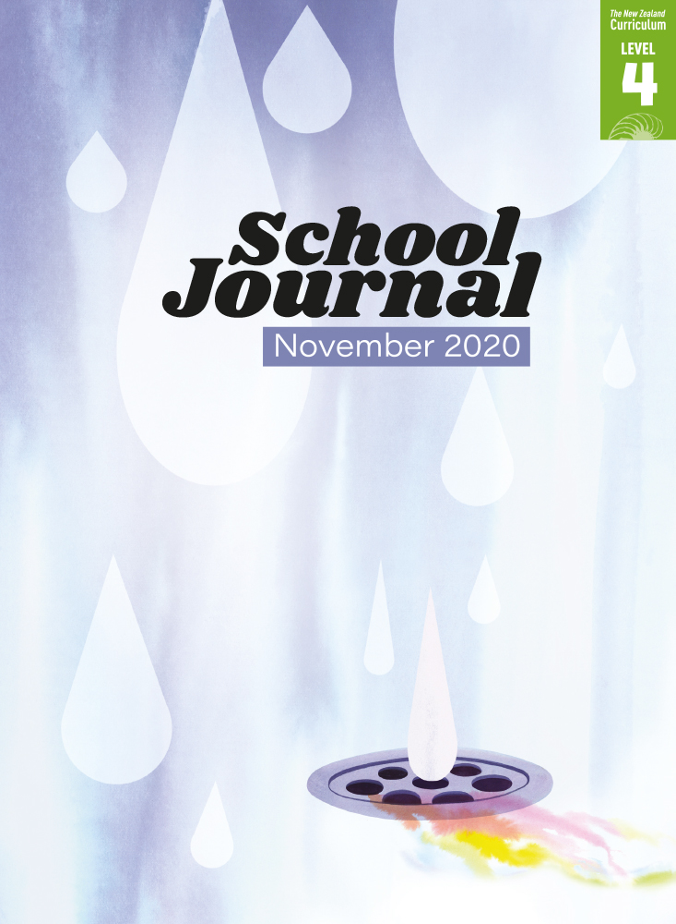

School Journal

Level 4, November 2020

**Year 7**

# Like, Share, Subscribe

by Cassandra Tse

The[Learning Progression Frameworks](https://curriculumprogresstools.education.govt.nz/lpf-tool/) describe significant signposts in reading and writing   
as students develop and apply their literacy knowledge and skills with increasing expertise from school entry to the end of year 10.

## Overview

This humorous play is a take on a familiar scenario: thoughtless online behaviour and our sometimes unhealthy relationships with screens. Although grossly exaggerated, Cassandra Tse’s point is still relevant, cleverly side-stepping the usual sides by portraying the adults getting it wrong and the kids getting it right.

A PDF of the text is available at [www.schooljournal.tki.org.nz](http://www.schooljournal.tki.org.nz)

## Themes

|  |  |  |  |
| --- | --- | --- | --- |
| * Use of social media | * Respect for others | * Whānau | * Privacy |

## Related texts

**“Meme and Me”** SJ L4 May 2016 | **“Dashing Doggies”** SJ L4 Nov 2016 | **“Kia Māia”** SJ L3 May 2020

## Strengthening reading behaviours (what to notice)

|  |  |
| --- | --- |
| Text structure and features | Requiring students to: |
| * Irony *EMMA reveals a new sign: No phones at the table. MUM and DAD gasp in horror.* * Metaphor and other figurative language and colloquial expressions *heart-to-heart; You’ve got to take the good with the beans; look at one another sheepishly; old fogies* * Dialogue *MUM. Jakey … sweetheart. You don’t understand. Being online influencers is our job. DAD. You’ve got to take the good with the beans. MUM. And, really, what’s so bad about a few photos at the dinner table every night?  EMMA. But it’s not just at dinner! You’re* always *taking photos*. | * use prior experience to understand that the situation is a reverse of what most families would experience (It may also require students to suspend disbelief that adults would behave like this and need strict guidelines from their children.) * use what they know about figurative and colloquial language as well as everyday conversational settings to visualise and understand the situation and each character’s motivation * use their experience of the nuances of conversation, especially within a family setting, either from their own experience and/or from reading fiction including plays, to follow the interactions between the children and parents and identify the problem in the story. |

|  |  |
| --- | --- |
| Vocabulary | |
| Possibly challenging words | easel, dramatically, exasperated, musings, connectedness, vegetarian, sponsored, influencers, dismissively, hilarious, exclusive, boundaries, addictive, aghast |

|  |
| --- |
| Helpful prior knowledge (pre-reading and introducing the text) |
| * Some understanding that social media online platforms are widely used in society * Some knowledge of blogging and social media * Some understanding that use of social media requires users to demonstrate social responsibility * Some readers may need support with the concepts of sponsored content and online influencers. |

## Possible reading and writing purposes

* Read and appreciate how the author has built mood and tension throughout this play
* Identify and explain why the use of social media becomes a family problem
* Explore and evaluate the way in which dialogue is used to convey the family problem
* Analyse the issues raised in the story around the use of social media.

See *Effective Literacy Practice in Years 5–8* for information about teaching comprehension strategies ([Teaching comprehension](https://literacyonline.tki.org.nz/Literacy-Online/Planning-for-my-students-needs/Effective-Literacy-Practice-Years-5-8/Teaching-comprehension))   
and for suggestions on using this text with your students ([Approaches to teaching reading](https://literacyonline.tki.org.nz/Literacy-Online/Planning-for-my-students-needs/Effective-Literacy-Practice-Years-5-8/Approaches-to-teaching-reading)).

## Possible curriculum contexts

This text has links to level 4 of *The New Zealand Curriculum* in: [**ENGLISH**](http://nzcurriculum.tki.org.nz/The-New-Zealand-Curriculum/English) [**HEALTH AND PHYSICAL EDUCATION**](https://nzcurriculum.tki.org.nz/The-New-Zealand-Curriculum/Health-and-physical-education)

## Understanding progress

The following aspects of progress are taken from the [Learning Progression Framework](https://curriculumprogresstools.education.govt.nz/lpf-tool/)s and relate to the specific learning tasks below. See the LPFs for more about how students develop expertise and make progress in these aspects:

* Reading for literary experience
* Making sense of text: using a processing system; using knowledge of text structure and features; vocabulary knowledge;   
  reading critically
* Using writing to think and organise for learning.

## Strengthening understanding through reading and writing

**Select from the following suggestions and adapt them** according to your students’ strengths, needs, and experiences.   
Note: Most of these activities lend themselves to students working in pairs or small groups.

* Ask the students what they thought of the author’s choice of the characters’ roles in the play. Draw out the idea that roles are reversed and how that creates humour. Ask them to share any “That reminds me of …” thoughts they had when reading the play.
* Have the students discuss with a partner any ideas about the use of social media that the play raises. They could use a Hu Su Pu system to find partners (**H**and **u**p when you are ready to discuss, **S**tand **u**p, **P**air **u**p with someone else who has their hand up). Each pair could then share their ideas and discuss with another pair or larger group.
* Clarify the issues raised in the play, such as using technology at the table, posting family life on social media, respecting privacy, creating fake lives, and sharing information for commercial gain. Draw out the students’ understanding of these issues. You could use a PMI template or adapt a 5Ws & H as appropriate, to explore these issues further. Ask the students to summarise the issues under one overarching concept, for example, online respect, online safety, rules for living in an online world.
* Have the students use the **SWOT** template at the end of this TSM to record the key points. They could do it as a jigsaw that could be pulled apart, used by individuals, and then put back together.
* Discuss how the story is conveyed through the dialogue and what it tells you about the attitudes and feelings of the characters. Have the students draw up four columns or boxes, write one of the characters’ names in each (Mum, Dad, Emma, Jake), and then jot down quotes that reveal each character’s point of view about the situation.
* Explore how people actually do talk in a group. The students could record themselves talking as a group as they share their thoughts about social media use. They could then try to transcribe the dialogue. Before they start, review ways they could punctuate dialogue to show new speakers, speakers trailing off in mid-sentence, people interrupting, and so on.
* You could use a vanishing cloze task to help English language learners notice sentence structure or punctuation. Copy a sentence onto the whiteboard and ask the students to read the sentence aloud together. Erase one or two words or punctuation marks and have them reread the sentence, inserting the missing parts from memory. Repeat until the whole sentence is erased.
* Examine the figurative and colloquial language in the play. Ask the students to identify and discuss the meaning of any examples such as, “dunno”, “sweeties”, “heart-to-heart”, “looked at each other sheepishly”, “old fogies”, “kiddo”.
* Ask the students to look critically at the following words from the stage directions (dramatically, exasperated, unimpressed, aghast, offended, embarrassed, nodding). In pairs, have them practise reading the dialogue in the manner described. *How do these words influence what you think of the characters?*
* Have the students perform the play in groups of four. They could video their plays and evaluate their dramatic interpretations, sharing these with the rest of the class to identify which performance was most effective.
* The students could create a flyer, poster, webpage, or video to promote online safety, using resources such as your school online policy or [Netsafe](https://www.netsafe.org.nz/the-kit/youth-action-squad/). Students with skills in te reo Māori or another language could use those skills to complete this activity.

|  |
| --- |
| “Like, Share, Subscribe” SWOT |

|  |  |  |  |
| --- | --- | --- | --- |
| **Strengths** | | **Weaknesses** | |
|  | **Issue: Using social media** | |  |
| **Opportunities** | **Threats** |
|  | |  | |

